Experiment No.: 02
Experiment Name: Implementation of Points and Lines Using Coordinate Plotting (Multiple Points, Horizontal Line, Vertical Line and Diagonal Lines with Slopes m = 1 and m = −1)
Problem-01: Drawing Multiple Points
Code & Output:
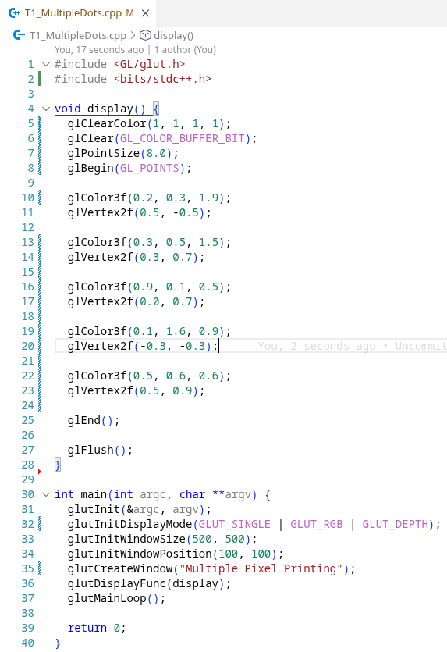
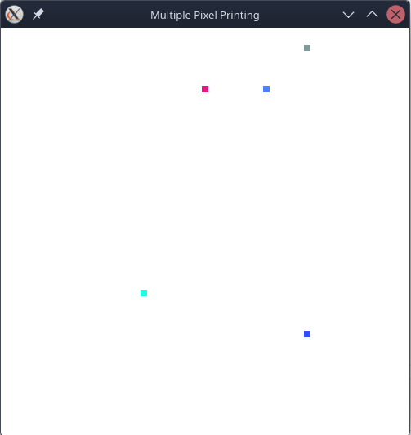
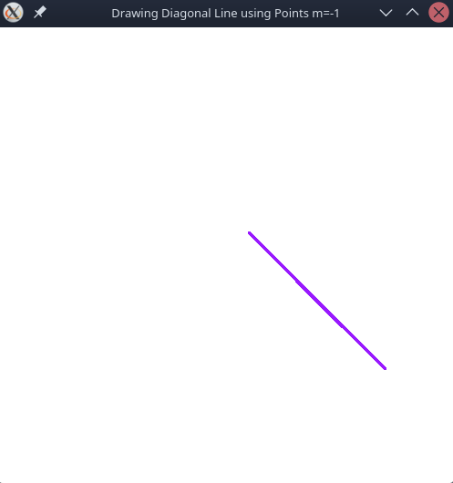

Problem-02: Drawing Horizontal Line using Points
Code & Output:
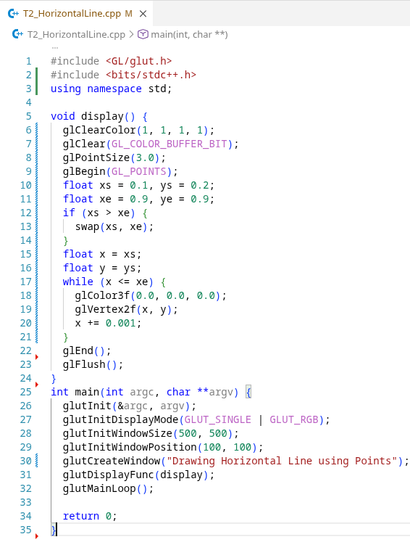

Problem-03: Drawing Vertical Line using Points
Code & Output:
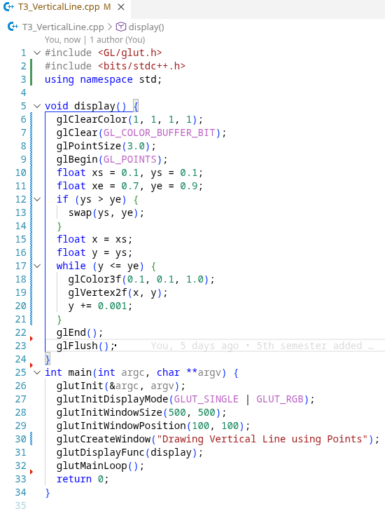

Problem-04: Drawing Diagonal Line using Points with Slopes m = 1
Code & Output:
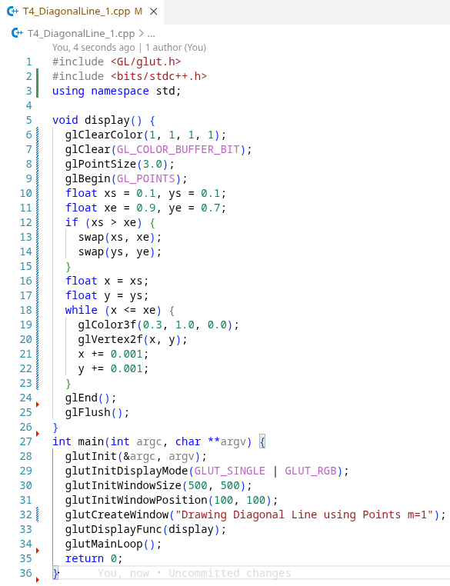

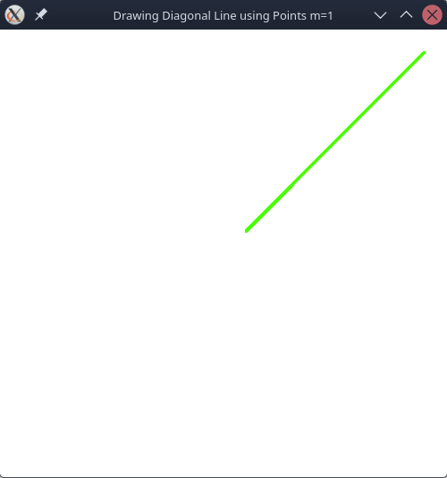
Problem-05: Drawing Horizontal Line using Points with Slopes m = −1
Code & Output:
